**Name**: Zoheir DEBBA

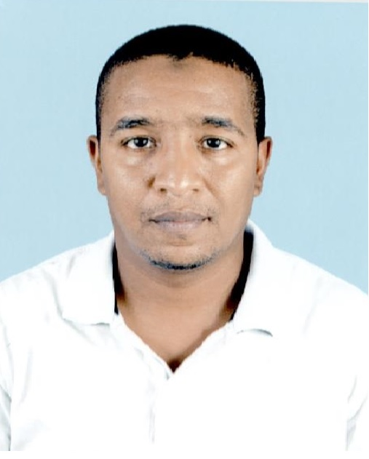

**Date of birth:**  July 05th 1983

**Address**: Bloc 476 N° 15-Hay Rimel 01-Touggourt /30200 Ouargla

ALGERIA

**E-mail:** ezo1983dz@hotmail.com

**Tel**: +213 770 63 48 39

**Family situation:** Married

**Level school:**

* Baccalaureate degree: 2002.
* University studding: From September 2002 to June 2007 at Maintenance and Industrial Safety Institute **(IMSI)** ORAN.

**Diploma**:

* State Engineer in Maintenance and Industrial Safety.

- Major: Instrumentation

- Engineer Thesis on: Communication Man / Machine by Terminal MAGELIS

**Languages**:

* **E**nglish (speaking, reading and writing).
* **F**rench (speaking, reading and writing).
* **A**rabic (speaking, reading and writing).

**Training**:

* **March 2007:** Training about improving the system of command of a boiler. /01 month at SONATRACH/ DP / RHOURD NOUSS. ILLIZI. ALGERIA
* **February 2008**: Training First Aids. /02 weeks
* **January 2010**: Industrial Safety Induction. /02 weeks
* **From du 23/06/2013 to 27/06/ 2013 :** Training about Control system ( PLC) Honeywell

**Experience**:

1. ***TARKIB CONSTRUCTION PRIVATE COMPANY is consists of:***

Construction area Oil and Gas

-Civil Engineering

-Mechanical Engineering

-Instrumentation Engineering

Project Pipeline and Metering in the National Center for Dispatching of Natural Gas (CNDG) SONATRACH /Algeria

I worked as:

***Instrument Supervisor:*** From March 2008 until December 2009

- Supervised the installation of all instruments.

- The wiring from field to automation room.

- Instruments, Metering and DCS commissioning.

1. ***SONATRACH / The National Center for Dispatching of Natural Gas (CNDG) is composed of 11 Pipeline each one consists of:***

* Filtration.
* Gas Metering Ramps with orifice plate metering.
* Regulation Ramps with Pressure Control Valve PCV.
* Line Valve and Gas Dispatching.

I worked as:

* ***Field Instrumentation Engineer:*** Maintenance of all field instrument and calibration of PCV from 2010 until September 2012 in CNDG
* ***Senior Field Instrumentation Engineer and Metering:*** Maintenance of all field instrument and Metering instrument calibration (PT,PDT and TT) and I assist the commissioning and startup of 03 Dispatching Natural Gas Pipeline from September 2012 until January 2015 in the same plant
* ***DCS Engineer:*** Recovery Command Control System from backup from 2015 to now

**Roles and responsibilities**:

* Responsible for complying with all safety, health, environmental policies and procedures of the company.
* Responsible for raising Safety issues inside the plant by raising Stop card.
* Insure good communication between all the team in plant.
* Must know the Personal Protective Elements and HSE in General.
* Attending the departmental safety, health and good housekeeping meetings, participates in plant inspection tours and takes active participation in implementing Company policies on safety, health, loss prevention and quality management.
* Observing all safety, fire and security rules and regulations, including the use of protective clothing and equipment and ensures that all personnel working in my area comply with safety procedures.
* Familiar with all gas dispatching operation and all preventive and curative maintenance procedure.
* Prepare Permit to Work for Senior Instrument Technician approval and perform operations and maintenance activities in accordance with established company Quality Systems and manufacturers' practices and procedures.
* Maintain tools and equipment in fully working order.
* Complete all necessary documents, forms, checklists and documentation as required prior to, during and subsequent to operations and maintenance activities.
* Troubles shoot and rectify Instrumentation and Control related faults within reasonable time frame to ensure maximum availability of equipment.
* Ensure all Instrumentation equipment is functioning within the designed parameters.
* Assist with overseeing the staff of any sub- contractors working on the terminal facilities associated with the Instrument and control equipment.
* Support the Senior Instrument Technician and Maintenance Supervisor in their duties.
* Provide support for any emergency response.
* Taking periodic log readings from indicators and gauges or instruments located on equipment in the operating area.
* Maintenance and Calibration of Daniel chromatograph GC500 with Moon 2000 software

**Miscellaneous:**

* Computer Literate: Word, Excel, Power point…

* Softwares: MATLAB, SIMULINK, STEP7, PL7, Moon2000 and XBT-L1000.

* Internet

* Driving License B category

**Hobbies:**

* Reading and Sport