niyas thaha • ROLLA • SHARJAH • UAE • niyasthaha010@gmail.com

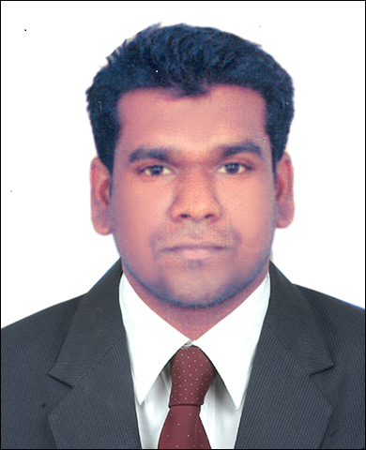

• +971524614164(M) • +971554684209(M)

Passport No H0406228
__________________________________________

OBJECTIVE
A highly motivated, honest and hard working Engineer with Bachelor’s degree in INSTRUMENTATION AND CONTROL ENGINEERING, seeking a challenging position that will provide an opportunity to utilize maximum potential for company’s growth with educational qualification, experience and skills.

EXPERIENCE SUMMARY
EXPERIENCE AS SERVICE ENGINEER-INSTRUMENTATION
- Installation, Commissioning, Calibration & Servicing of XRF Analyzers, Particle Size Analyzers, Moisture Analyzers, Fusion Bead and Weighing Balances.

- Done the whole Servicing of the instruments which includes the Circuit board, Electronic parts, x-ray tube and laser source.

- Familiar with ASTM practices and preparation of samples for validating Analytical Methods.
- Providing technical training to customers and technical support personnel.

WORK EXPERIENCE
- Company Volga Instruments Pvt Ltd, Mumbai.
- Designation Instrumentation Engineer.
- Duration 02/05/2013 to 31/08/2016.
Volga Instruments Private Limited is a System integrator of Oxford Instruments-XRF Analyzers (U.K. based MNC), CILAS Particle Size & Shape Analyzers (France based MNC), Metler Toledo Weighing Balance and Moisture Analyzers (Switzerland based MNC) etc, that Offers instrumentation solutions to several industries in quality control.

MAJOR CLIENTS:
Oil and Natural Gas Corporation limited (ONGC), Bharat Petroleum Corporation Limited (BPCL), Indian Oil Corporation Limited (IOCL), Hindustan Petroleum Corporation Limited (HPCL), Reliance Industries Limited (RIL), Bhabha Atomic Research Centre (BARC), Bharat Heavy Electricals Limited (BHEL), Ultratech Cement, Ambuja Cement, ACC Cement, Birla Cement, Reliance Cementation Private Limited, etc.

JOB PROFILE:

- Installed, calibrated, commissioned and servicing various models of XRF Analyzers in various Cement industries, Petrochemical industries and Iron ore industries all over India. The XRF Analyzers includes various models of Oxford Instruments like Lab-X 3000, Lab-X 3500, Lab-X 3500S, Lab-X 3500SCL, X-Supreme8000,X Met 7500.
- Installed and commissioned various models of CILAS Particle Size Analyzers in various Cement industries, Biochemical industries, Ceramic industries, Polymer industries, Chemical industries and pigment manufacturing industries. The CILAS Particle Size Analyzers includes various models like Particle Size Analyzer 990, Particle Size Analyzer 1090, Particle Size Analyzer 1190, Particle Size Analyzer 930, Particle Size Analyzer 1064 and Shape Analyzer etc. Calibration of these instruments is also done.
- Installation, calibration, commissioning and maintenance of MDX 1000, 1080(WD XRF), ED 2000 in petroleum industries and forensic laboratories.
- Installation, calibration and commissioning of PHOENIX 1000S fusion bead making instrument by(XRF Technologies)

MY RESPONSIBILITIES:
- Attending all the service call as per the schedule provided to the service team.
- Intimating the customer prior to the service visit to the site.
- Maintaining service tool kit as per the machine to be serviced.
- Providing the best service for the customer satisfaction.
- Calibrating the machine after maintenance.
- Recommending required spares and suggestions for trouble free operation of the equipment.
- Intimating service manager for the urgent requirement of spares from the site.
- Preparing service report and monthly report and send to Assistant Service Manager.
- Coordinating with sales professionals in giving demo and presentations of instruments.

ACADEMIC PERFORMANCE

YEAR | COURSE | INSTITUTE | UNIVERSITY/BOARD | PERCENTAGE
2009-2013 | B.Tech Instrumentatation and Control | N.S.S college of Engineering Palakkad | Calicut university Calicut | 65%
2006-2008 | Higher Secondary | Govt.H.S.S Bhoothakulam, Kollam | HSE,KERALA | 84%
2006 | Secondary | Govt.H.S.S Bhoothakulam Kollam | STATE BOARD KERALA | 94%

TECHNICAL SKILLS

- Operating system : windows
- Programming skills : C,C++
- Application software used : Ms Word, Ms Power Point, Ms Excel, AUTOCAD
- Familiar with Yokogawa DCS (Yokogawa CS 3000), PLC (Prosafe-RS), SCADA (Stardom/Fast tools), Fieldbus (FFO) & Field instruments.

GENERAL INFORMATION
Name: NIYAS THAHA
Date of Birth: 11-05-1990
Sex: Male
Father: THAHA
Address: Sharjah, UAE
Visa Status: Visiting Visa (visa expiry 09/12/2016)
Email: niyasthaha010@gmail.com
Phone: 00971524614164(M), 00971554684209(M)
Languages known: English, Hindi, Malayalam (native)

PASSPORT DETAILS:
Passport no: H0406228
Place of issue: Thiruvananthapuram
Date of issue: 2-9-2008
Date of expiry: 1-9-2018

DECLARATION

I hereby declare that the information stated above is correct to the best of my knowledge, and no part thereof has been intentionally distorted or misrepresented.

NIYAS THAHA

