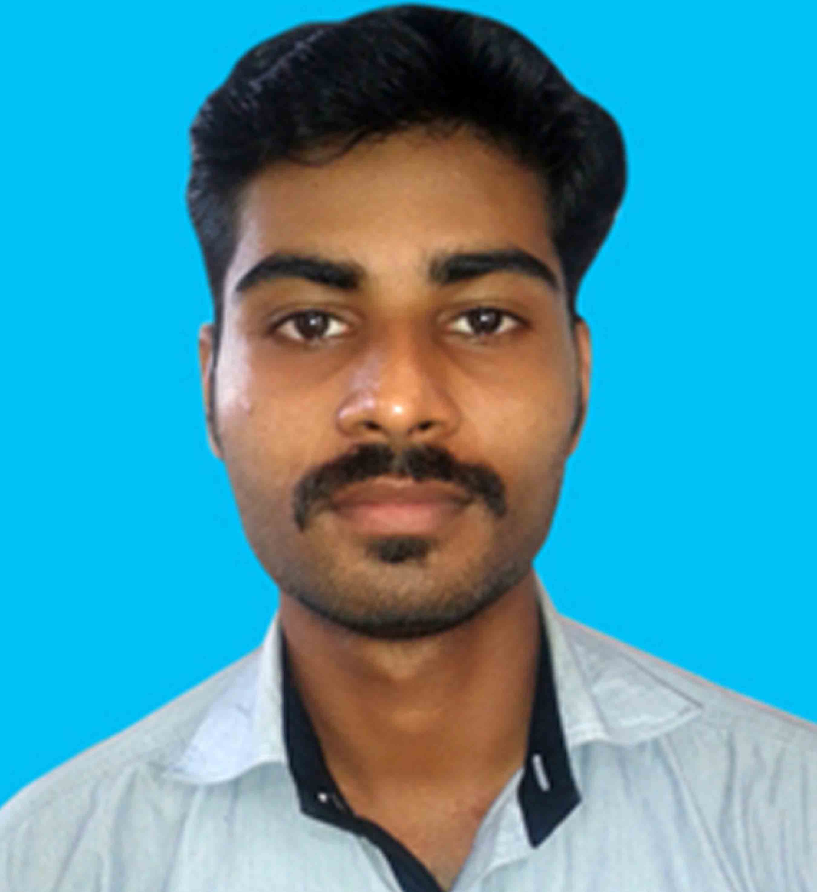
DIPU KP
Mob: +968.96458230
E-mail: dipu55kp@gmail.com

CARRIER OBJECTIVES:

Intend to build a career with leading corporate hi-tech environment where I can utilize my skills for developing my career for the growth of the organization that will help to explore myself fully and realize my potential.

ACADEMIC QUALIFICATION:
Course | University/Board | Percentage | Year of Passing
MCA | MS University | 65.8 | 2015
B.Sc: CS | MS University | 65.1% | 2012
+2 | State Board | 77% | 2009
10th | State Board | 48% | 2007

TECHNICAL QUALIFICATION:
Operating System : Windows 7 and Later,
Database : SQL Server 2008 and Later,
Languages : Java, OOPS,
Design : Asp.Net, Dream weaver

CERTIFICATION:

Diploma in Computer Hardware and Networking

ACADEMIC PROJECT:
Project Name : CA Auditing Portal
Project duration : 6 months
Company name : Visiware technologies
Language of Implementation : ASP.Net
Backend Tool : MS-Access
Operating System : Windows XP/07
Description: CA Auditing Portal is web based application developed for the use of Chartered Accountants for Balance Sheet verification, Tax calculator, Online discussion tool for clients, online document upload etc.

PROFESSIONAL EXPERIENCE:
Subash Technosis Private Limited Web Developer Jul’15 – Jun’16
Profile: Leading Organization in Specialized in UX & SEO and Web Designing.

Role;

- Design new websites and maintenance of existing websites
- Design landing pages and email addresses.
- Trouble shooting website that encounter errors
- Design website user-friendly
- Testing website, to function in different browsers at different resolutions.

TECHNICAL SKILLS:
Languages : Proficient in JavaScript, CSS, HTML, XHTML, Java.Net, and python.
Adobe Suite : Skilled in Adobe CS5.5 Web Premium –Dreamweaver, Flash catalyst,
iflash professional, Photoshop.
Web Tools : Skilled in flash, Experienced in using REST, SOAP and XML familiar with
FrontPage, Web trends, and validation tools.

STRENGTHS:
- Strong determination
- Positive Thinking
- Good Learner by Observation
- Problem Solving Skills

PERSONAL INFORMATION:
Name : K.P. Dipu
Age & Date of birth : 26, 13-10-1989
Sex : Male
Languages known : English, Tamil & Malayalam.
Interests : Drawing, painting, caroms, etc…
Contact number : +968.96458230

