**CURRICULUM VITAE**

**PERSONAL DATA**

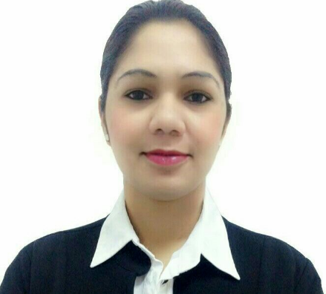Name: Gleta Dsilva

Date of Birth: 11th September, 1987

Sex: Female

Nationality: Indian

Marital Status: Single

Current Location: Oman - Muscat

Passport No.: G1835538

Mobile No.: +968 94736508

Email address: [gleta_dsilva@yahoo.com](mailto:gleta_dsilva@yahoo.com)

**PERSONAL PROFILE**________________________________________________________________________________________

Dynamic, Enthusiastic, Excellent communication skills, Good confidence level and Maintain high-level team spirit

. ·       Hard working and Result Oriented.

·         Dedicated and self-Reliant.

·         Strong interpersonal skills and flexible.

·         Confident and optimistic team building.

·         Excellent personal development & communication skills.

·         Friendly and an extrovert person.

·         A good Team player.

·         Conducting team building activities.

·         Attention to detail.

·         Team & Time Managemen**t.**

**SUMMARY**

To give my best in my professional pursuit for overall benefit and growth of the company that I serve by facing the challenges. I will show my caliber and gain some experience & Seeking a challenging position to work in globally competitive environment that will enhance my career whereby I can utilize my current skills and make significant contribution with strong work ethics and diligence that yield both job satisfaction and steady peace professional growth & To be an astute learner and the best performer in your organization. So that I can build an innovative career in your esteemed organization by using my skills and other significant talents.

**EDUCATIONIONAL QUALIFICATIONS**

Year 2005 **“Guardian Angel Higher Secondary School” Goa – India (Goa Board)**

H.S.C. Higher Secondary School Certificate

Year 2003 **“Guardian Angel High School” Goa – India (Goa Board)**

S.S.C. Secondary School Certificate

**ADDITIONAL QUALIFICATION**

2003 **“InfoTech Computer Institute” – 1 month Training**

**IT Knowledge** Basic Computer

Microsoft Office (Word, Excel)

Power Point Presentation

**Language Skills** English: Written & Spoken

Hindi: Written & Spoken

Konkani: Native Language

**WORK EXPERIENCE**

11/2007 – 02/2012 **Office Assistant -** **Life Insurance Corporation of India – Goa, India**

* Maintaining paper work
* Monitoring and inspection on payments
* Data entry regarding payments of installments
* Attending Phone Calls.
* Maintaining Appointment
* Customer service

01/2013 – 03/2015 **Telephone Operator Cum Secretary - H.E. Dr. Omar Zawawi’s Estate**

**(HM Advisor of External Laison) and Chairman of OMZEST Group of**

**Companies, Muscat, Oman**

* Billing & Preparing Vouchers for payments
* Handling petty cash and recording office expenditures
* Basic accounting for daily expenses
* Maintain and update of data
* Answer phones and transfer to the appropriate staff members
* Connecting conference calls
* Administrative duties including Fax, Filing and managing incoming and outgoing mails
* Handling inbound and outbound calls
* Maintain a high level of accuracy confidentiality concerning financial and employee files.
* Data entry for day to day transactions and attendance records
* Responsible for handling calls in a courteous, friendly and professional manner according to company procedures.
* Maintain a record of expiry of Passports, visas, labor cards, ID, health card etc.
* Coordinate & follow up with the PRO to ensure timely renewals.
* Maintaining knowledge of promotions producers.
* Handling Events &Presentations.
* Create and maintain database records.
* Maintaining staffs records
* Maintaining inventory records.
* Handling official get together.
* Ensuring opening and closing checklist are completed on daily basis.
* Following cash handling procedures.
* Escorting guests when and then required.
* Reporting to manager. &Undertaking daily routine works of faxes, scans and mailing.
* Handling official and Administrative work etc.
* Being a good professional by having a pleasant smile always
* Assisting HR manager  approvals for employees proceeding on Annual leave, emergency leave, cancellations, renewing visa etc.
* Proper management of passports and other important documents.
* Coordinate with HR for new visa applications, labor cards, ID, employee arrival, cancellations etc.
* All other routine administration work.

**SKILLS:**

* Willingness to learn
* Working in a team environment.
* Excellent knowledge of office systems

**HOBBIES & INTERESTS:**

* Travelling
* Interacting with people

**REFERENCES**

* Available upon request

**DECLARATION**

I hereby declare that the above facts given by me are true to the best of my knowledge and belief.

Gleta Dsilva