**In the name of Allah the most merciful the most gracious**

|  |
| --- |
| Objectives |

|  |
| --- |
| Personal Information |

**“God willing to secure a position so that I may got an opportunity to utilize my skills and knowledge to their very best and prove how much of an asset I can employee of company because without a doubt I have all the confidence in my self and know what high standard is, and what is takes to live up to that standard”**

|  |
| --- |
| Wandi Molvi Sahib Kot Chandna  P/o: Kala Bagh Teh: Isa Khel  Distt: Mianwali , Punjab , Pakistan. |

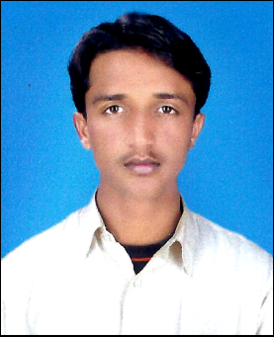Name : Wasim Akram Father’s Name : Nizaam Din Date of Birth : 04/12/1989 CNIC # : 38301-0983835-5 Passport : DP1328351 Qualification : D.A.E (Civil) Contact # : 0336-7286565 Marital States : Merried Nationality : Pakistani Email Address : irfanullahkhan56@gmail.com Languages : Urdu,English,Saraiki,Punjabi. Domical : Mianwali,Punjab,Pakistan. Address **:**

|  |
| --- |
| Qualification |

|  |  |  |  |
| --- | --- | --- | --- |
| **Degree / Diploma** | **Marks** | **Year** | **Collage / University** |
| Metric | 455/850 | 2008 | BISE Sargodha |
| D.A.E (Civil) | 2449/3300 | 2012 | PBTE Lahore |

|  |
| --- |
| Professional Qualification |

* One Year Diploma of Surveyor Trade in Punjab Board of Technical Education Lahore with Pak Arab Training Center Rawalpindi.

|  |
| --- |
| Experience |

* Worked in Recent Construction Co.(Pvt) Ltd.

From 08/02/2011 to 10/10/2013 as a **Safety Supervisor.**

|  |
| --- |
| Hobbies |

* **Cricket , Volly Ball , Islamic Books Reading , News Paper , PTV News only.**

|  |
| --- |
| Reference |

* **Could be provided on demand.**