ARSHA. A (MBA- Finance)
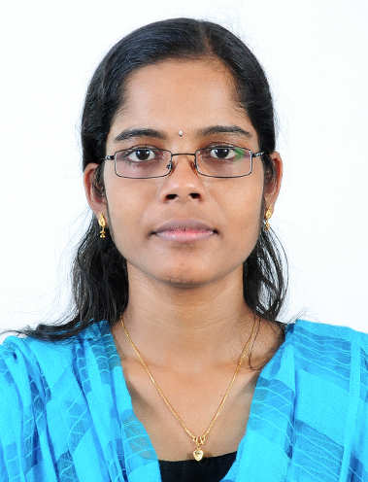
KIZHAKOL HOUSE
RAMAPURAM P O
RAMAPURAM
KOTTAYAM
KERALA-686591
E-mail:arshaampi@gmail.com
Mob: 9961023310
PROFESSIONAL OBJECTIVE:
Looking for a challenging job in my field of interest in Management and Banking sector to show my proven and acquire better knowledge and career growth.
EDUCATIONAL SYNOPSIS
Course | Institution | University/ Board | Year of Passing | Percentage of marks
MBA | FISAT Business School, (Angamaly, Eranakulam, Kerala) | Mhatma Gandhi University | 2011 | 75%
BBA | Mar Augusthinose College (Ramapuram, Kottayam) | Mahatma Gandhi University | 2009 | 81%
Plus Two | C. H.S.S (Chattanchal, Kasaragod) | State Board | 2005 | 65%
S.S.L.C | C.H.S.S (Chattanchal, Kasaragod) | State Board | 2004 | 75%

PROJECTS DONE
A study on Credit Appraisal mechanism in Corporation Bank Head Office, Mangalore
Duration: 2 Month
Details: A collective study about the credit appraisal techniques and credit appraisal methods using the bank
Organization Study at Lunar Rubber’s (P) Ltd
Duration: 1 Month
Details: A collective study of the Organization and its Departments
A study on Labour Absenteeism at Hindustan Newsprint Ltd, Mevelloor, Kottayam
Duration: 1Month
Details: A study on the nature and reasons of absenteeism at Hindustan Newsprint Ltd
Social Project done at Ramapuram Gramapanchayat, Kottayam (dt)
Topic: A study on reasons for Unemployment
Duration: 1 Month
EXPERIENCE:
Working with the ICICI Bank Ltd as the post of Officer, since 28 February 2012- Currently
KEY REPONSIBILITIES:
Handling Savings A/c, NRI A/c and Current A/c.
Responsible for achieving the monthly sales targets.
Cross sell new product and service opportunities (Personal Loan, Home Loan, Credit Card, Jewel Loan, Life Insurance, and Mutual Fund)
Resolve customer queries and issues.
Ensure customer satisfaction.
ACHIEVEMENTS:
Secured Exemplary Performance Conclave Award from Mr. Jayakumar Nair (Zonal Head, ICICI Bank Ltd)
Secured Award of Excellence and Outstanding Achievements in Star of South.
Best Performer in “OUTLIER “contest in May 2014.
Held as one of the executive committee member and conducted National Seminar on Consolidation of Banks at Avenue Centre, Cochin.
Pursued Business Skill Development Programme by MSME, Government of India at FISAT Business School and got certificate from MSME
Worked as management trainee with Executive Events Cochin, for conducting the 62nd annual conference of Cardiological Society of India at Le Meridian, Cochin.
COMPUTER SKILL:

- Basic knowledge in MS – Office and Windows
STRENGTHS:
- Can initiate and motivate a team towards a common goal
- Adaptability to varying environment
- Ability to work in a team
- Ability to interact with people easily.

PERSONAL SPECIFICS
Date of Birth : 23/03/1987
Gender : Female
Nationality : Indian
Religion : Hindu
Marital Status : Single
Languages known : English, Hindi, Malayalam, Tamil
PASSPORT DETAILS:
Passport Number: J6642337
Date of Issue: 14/07/2011
Date if expiry: 13/07/2021

REFERENCES:
Prof. T.N. Ramakumar, Mr. K. Rajkumar
Faculty, FISAT Business School Desk Officer
Eranakulam, Kerala HR Departmant
Mob : 09446515546 Corporation Bank, Head Office
Mangalore
DECLARATION
I declare that the details furnished above are true to my knowledge. It will be my pleasure to provide any further details if required.
ARSHA. A

