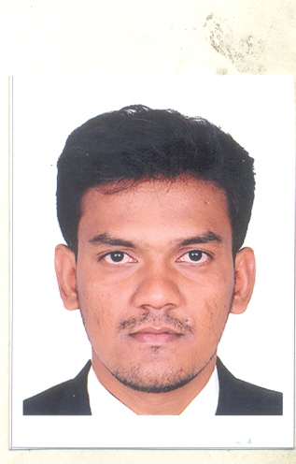

M A N I K U M A R. B - B.E (MechanicalEngineering) **with 7 YearsExperience in Proposal, Estimation&Planning.**

Contact: 77085-26786 rediconz@gmail.com

**ADDRESS FOR COMMUNICATION**

100,Kankollpattinam,

Puthupattinam (PO),

Namboothalai (Via),

Ramanathapuram(Dist)

Contact: 00968-94525179

rediconz@gmail.com

**PROFILE:**

Completed B.E (Mechanical Engineering) with first class in Institute of Road & Transport Technology in 2008 & Join in **Cethar Limited** & worked as **Proposal**, **Estimation &Tendering Engineer** up to November 2012.From November 2012 to September 2014 **Worked as Proposal & Estimation in C&H Services in Thermax Limited.**

**Currently Working as Proposal, Estimation Engineer RAY International L.L.C, in OMAN.**

**The Following is the Job profile in the Organization.**

**Proposal, Estimation &Planning:**

**1. Proposal& Planning:**

* Review the tender document for Boiler / Steam Turbine / Coolers & Heaters & all relevant portions of the tender received from Marketing.
* Prepare our Proposal as per the tender requirement.
* Co-ordinate with our Sub-Vendors for Bought out items..
* Review the Offer proposed by the sub-vendors for Bought out items.
* Compile the Offer prepared for the tender document
* Prepare L1, L2 & L3 Schedule for offered Package.

**2. Estimation& Contract Management:**

* Prepare the bill of quantities for the project.
* Prepare the enquiries for the Bought out items & Send to various vendors.
* Negotiate with vendors for both technical & commercial Part.
* Estimate for the Project.
* Compare our Estimate price with our earlier contract projects.
* Prepare budget for the Project
* Monitoring the Project.
* Co-ordinate with Sub contractors.
* Monitor the invoicing (respect to Off shore & Onshore products)
* Update the feedback (both technical & Commercial) if any, in our future proposal

# QUALIFICATION:

|  |  |  |  |  |
| --- | --- | --- | --- | --- |
| **COURSE** | **BOARD/**  **UNIVERSITY** | **INSTITUTION** | **PERFORMANCE**  **%** | **YEAR OF PASSING** |
| B.E **(M**echanical **E**ngineering) | Anna University | Institute Of Road And Transport Technology, Erode | 76.98 | 2008 |
| H.S.C | Matriculation | Alagappa Matriculation Higher Secondary School, Karaikudi. | 89.5 | 2004 |
| S.S.L.C | Matriculation | Alagappa Matriculation Higher Secondary School, Karaikudi. | 85.6 | 2002 |

**JOB STRENGTH:**

* + Capability of doing **Proposal & Estimation through** ERP.
  + Cost Analysis through MS Software.
  + Had done **Proposal for our Major Milestone Projects in CFBC / PC Subcritical & Supercritical Projects in EPC Basis**.

**MAJOR UTILITY PROJECTS HANDLED SO FAR:**

* + M/s.ACB(India) Ltd -2x135MW EPC Package (CFBC Boiler)
  + M/s.SCL-2x150MW EPC Package (CFBC Boiler)
  + M/s.IBEUL-2x350MW Boiler Package (PC Fired Boiler)
  + M/s.JAL-2x60MW (CFBC Boiler)
  + M/s.SKS Power Gen (P) Ltd-4x300MW EPC Package (PC Fired Boiler)
  + M/s. IBEUL-1x660MW Boiler Package (Once Through Supercritical PC Fired Boiler)

**FIELD OF INTEREST:**

* + Power Plant Engineering
  + Economic & Cost Analysis

**SOFTWARE EXPOSURE:**

* MODELLING **-** Pro/Engineer 2001
* DRAFTING  **-** AutoCAD 2004

**CO –CURRICULAR ACTIVITIES:**

Presented paper on Cost Optimization in

* + Bed Ash Cooling System in CFBC Boiler
  + Once Through Super critical PC Fired Boiler
  + Actively took part in Technical Programme on **Steam turbine & Generator in Harbin Turbine Company Limited in China.**

**ACIEVEMENTS:**

* + Done Proposal, Estimation & Tendering for the above mentioned Utility Projects.
  + Actively took part in launch of Supercritical technology from Cethar.

**PERSONAL PROFILE:**

Date of birth : 19/04/1986

Father’s Name : Mr.R.Boominathan

Mother’s name : Mrs.B.Selvakkannu

Hobbies : Painting, Listening music, Fishing

Language proficiency : English, Tamil

Passport details : H O534875 , Validity 21/09/2018

Marital Status : Single

# I, MANIKUMAR.B do hereby declare that the above mentioned details are true to the best of my knowledge

**Station : Oman**

**Date : (B.MANIKUMAR)**

