**RESUME**

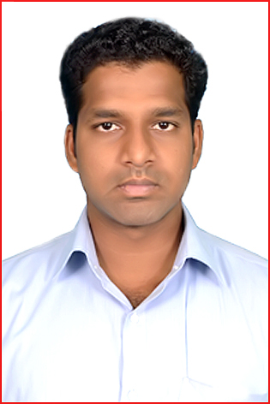

**BHARATHI.R**

**Mob: +919751752580**

**Email:rbrb.ins@gmail.com**

**Objective:**

**To work in a challenging and growth oriented environment, unifying my progress with the team and organizations in which I work.**

**Educational Qualification:**

**Degree : Diploma in Instrumentation & Control Engineering.**

**(2008-2011)**

**Institution : Srinivasa Polytechnic College,**

**Srinivasa Nagar, Kalamavur-622502**

**Pudukkottai. (Dist)**

**Year of Passing : April 2011**

**Course : ITI in Instrument Mechanic [2004-2006]**

**Institution : Government Industrial Training Institute**

**Ambattur.Chennai-600098.**

**Year of Passing : July-2006.**

**Abroad experience:**

|  |  |
| --- | --- |
| **COMPANY** | **Saudi Arabian Kentz** |
| **SITE** | **Saudi INternation Petrochemical Co.** |
| **DESTINATION** | **INSTRUMENT TECHNICIAN** |
| **PERIOD** | **June 2014 – present** |

|  |  |
| --- | --- |
| **COMPANY** | **Emco-Qatar** |
| **SITE** | **Qatar foundation** |
| **DESTINATION** | **INSTRUMENT TECHNICIAN** |
| **PERIOD** | **March’ 2012 to April’ 2014** |

**Indian Experience :**

|  |  |
| --- | --- |
| **COMPANY** | **Franklin Instrumentation Erection & Maintenance Pvt, Ltd.** |
| **SITE** | **CHENNAI PETROLEUM CORPORATION LTD** |
| **DESTINATION** | **INSTRUMENT TECHNICIAN** |
| **PERIOD** | **May’ 2011 to March’ 2012** |

|  |  |
| --- | --- |
| **COMPANY** | **Anacon Process Control Pvt Ltd.** |
| **SITE** | **CHENNAI PETROLEUM CORPORATION LTD** |
| **DESTINATION** | **INSTRUMENT TECHNICIAN** |
| **PERIOD** | **Aug’ 2006 to June’ 2008.** |

**Worked Area:**

* **Refinery & Power plant instrumentation, maintenance, project, shut down.**
* **Worked FCCU, CRUDE & WAX. Plant.**
* **LEP, OM &S, ETP, TTP and Analysers.**

**Nature of Work:**

* **Calibration of pressure, level and Temperature gauges.**
* **Calibration of field instruments like Switches for pressure, level, and flow.**
* **Wiring and termination of cables in junction boxes, panels etc.**
* **Calibration of field instruments Transmitters for pressure, flow, level and Temperature.**

**New Project:**

* **Experience in loop checking and comminsioning of all field instruments**
* **Have experience in carrying out the instrument erection and commissioning activities with reference to the following construction document instrument cable schedule.**

1. **Instument / JB Location drawings**
2. **Logic Drawing**
3. **Control scheme drawing**
4. **Hook up drawing**

**Personal Details :**

**Name : BHARATHI. R**

**Father’s Name : RAJENDRAN. N**

**Address : 1/36, NORTH STREET**

**KANNARAMPATTU (Po),**

**ULUNDURPET (TK)**

**VILLUPURAM – 607 203.**

**Date of Birth : 30.07.1986**

**Sex : Male**

**Religion : Hindu**

**Nationality : Indian**

**Marital Status : Single**

**Languages : Tamil & English**

**Mobile : +919751752580**

**Mail – ID : rbrb.ins@gmail.com**

**Passport Details :**

**Passport No : J9410657**

**Date of Issue : 18/11/2011**

**Place of Issue : Chennai**

**Date of Expiry : 17/11/2021**

**Declaration**

**I hereby declare that information provided above is True, Complete and Correct to the best of my Knowledge and belief.**

**Thanking you**

**Yours Sincerely,**

**Place : ( BHARATHI. R )**

**Date :**