RESUME

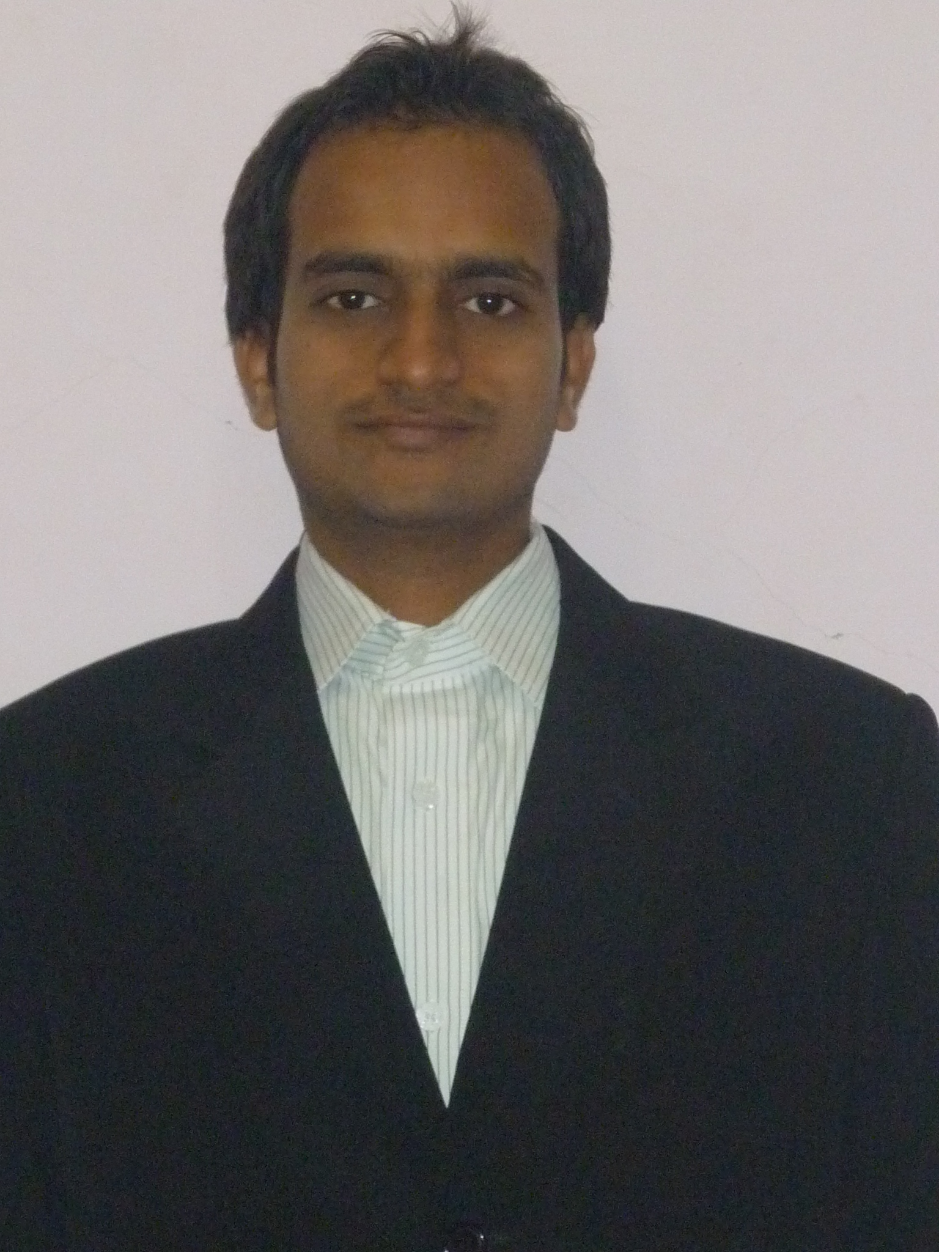

Add: DIP-2 Name: Mohd Aslam
DUBAI-UAE Email: md.aslam1024@gmail.com
Mobile: +971529938700

Career Objective:

I see my career as a continuous process of learning and applying my knowledge to my working domain with a focus on innovation and excellence & to hold a strategic position in a dynamic organization which demands high degree of excellence, competency, hard work which can provide the scope of growth for personal along with organization.

Resume Summary:
- 4 yrs experience in electrical & instrumentation industry.
- Design & Estimate the quantities for Electrical, Fire Detection, Voice Alarm & Public Address, Emergency/Exit lighting, VESDA, CCTV, Access control, SMATV, Intercom and Gate Barrier systems.
- Installation & commissioning of PLC System (Allen Bradley & Siemens), S/W Development.

Professional Strength:
- Understanding & reviewing client requirement through documents, specification & drawings for the design, selection and providing priced bill of quantities.
- Following the international standards which are NFPA, NEC, BS, IS, DEWA, NBC, FSAI and so on.
- Preparation of Design and estimation for the proposed building as per requirement of concerned authority of jurisdiction.
- Preparation of quotation as per the client requirements, Drawings & Specification from the supplied bid document.
- Study tender document to understand techno-commercial scope. Generate RFI for any missing information from tender document.
- Selection of the type of the system & product manufacture as per specification, drawings & client requirement.
- Plan & Implement standard pricing strategies for efficient & effective estimation with workable solution.
- Co-ordination with sales for the proposal submitted to the client. Arranging a meeting with the client if client needs any technical clarification.
- Revising the quotation with value engineering to match client’s requirement.
- Maintaining log of enquires quotes & updated status.
- Preparing compliance statement for the project specification after receiving LOI from the client.

Professional Experience:
From 07/July/2013 to Present Naffco Electro-Mechanical LLC (Dubai FZCO)

Designation: Instrumentation Engineer.

Responsibility:

- Served as Project engineer for Automation projects ranging from minor control system upgrades and modification to new system installation
- Technical skills towards design, documentation, implementation and testing of PLC,SCADA,HMI and other applications
- Installation and commissioning of PLC systems, S/W development and other Industrial Automation related activities
- PLC Programming Software: Allen Bradley (Micrologx 1000,SLC 5/03),
- Ability to work as a key member of a multi-disciplinary project team
- Ability to work flexible hours including evenings to meet business needs

Professional Experience:
From 06/2011 to 03/2013 GENT-TECH AUTOMATION (HYD)

Professional Development:
B Tech: - ELECTRONICS & INSTRUMENTATION ENGINEERING-(2007-2011).
COLLEGE: - Royal Institute of Technology & Science, Chevella, HYDERABAD.
PERCENTAGE: -60%
UNIVERSITY: - JAWAHAR LAL NEHRU TECHNOLOGY UNIVERSITY HYDERABAD.

Industrial Automation Exposure:
- SCADA (Wonder Ware’s Intouch)
- PLC (Allen Bradley, Modicon & Siemens)
PRECON AUTOMATION & SYSTEM PVT LTD. MUMBAI

Technical Skills:
- Certification in Automation [Siemens s7-300 PLC] from Advance training Institute [ATI] Hyderabad, A.P.
- Excellent in Basic computers.
- MS Office, MS Excel and Internet.

Soft Skills:

- Good Communication Skills
- Documentation & preparation skills.
- Willing to learning & self improvement.
- Willing spend extra time to finish work to achieve desired results.
- Good problem solving skills.
- Scored 6.0(overall) Bands in IELTS (International English Language Test System)

Personal Details:

Name : Mohd. Aslam
Father’s Name : Mansoor Shailk
Date of Birth : 26/12/1988
Nationality : Indian
Gender : Male
Religion : Muslim
Languages Known : English, Hindi & Urdu
Passport No. : J 5085777
Place of issue : Hyderabad AP
Date of Issue : 03-06-2011
Date of Expiry : 24-05-2021

Declaration:

I hereby assure you that the above-mentioned information is accurate and true to the best of my knowledge. In the event of me being selected, you are assured of my wholehearted effort to carry out my duties to the best of my ability.

Thanking you for your kind attention and look forward for a favorable response.

(MOHD ASLAM)

