
MINU VARGHESE
Kizhakada House, Thripperumthura P.O. Chennithala, Mavelikara- 690105
minuvkens31@gmail.com
0096892548368/ 0096896097028/ 00919526683386

MIDDLE MANAGEMENT PROFESSIONAL
Seeking senior level assignments in Documentation with an organization of repute, preferably in Oil & Gas/ Construction industry

Profile Summary

- Result oriented professional offering more than 9 years’ of illustrative organisational experience in Project Management, Document Control, Electronic Document Management System (EDMS), Training & Development, Office Administration and Monthly Payroll Management.
- Adept at handling daily activities in co-ordination with internal / external departments for ensuring smooth business operations. Experience in updating data to maintain departmental records and databases.
- Resourceful at developing procedures, service standards, and operational policies with proven ability to reduce the running cost of the unit by planning & implementing effective control measures.

Sound know-how of VBC and FoxPro commands. Hands-on experience in developing teams, facilitating functioning in a uniform environment, broadening work scope, bringing process rigor and developing modules. Demonstrated excellence in maintaining Project Filing Systems & Electronic Filing System, filing project documents, transmitting project documentation, storing documentation, registering documents, etc. Strong problem solving & technical skills coupled with confident decision making for enabling effective solutions leading to high customer satisfaction and low operational costs.
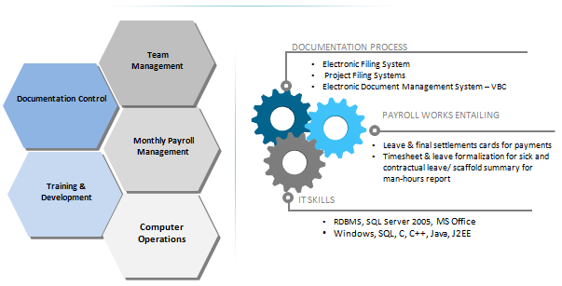

Core Competencies

- Competent of setting up and maintaining an EDMS system and proficient to understand the interface between other systems (client, contractors, suppliers, etc.).
- Maintenance and operation of Internet environment Document Management System (DMS) such as Visual Byblos Cyberspace (VBC) and ASSAI.
- Familiar with Technical Documentation (Engineering Documents, Specifications, drawings, design analysis, quality manuals, software, external standards, validation protocols, department procedures and work instructions, etc.).
- Rendering support to the process by ensuring the latest maintained documentation is available and updates are issued in a timely manner; handling the formatting of files and documents
- Managing formatting of documents for clients as per their specifications and deadlines
- Overseeing client database updation; processing of tables & images
- Monitoring quality & verification of proof-read documents; sustaining process document control process (i.e. tracking and reporting on document status); administering receipt of that information and registering in VBC
- Implementing process handover procedure and ensuring necessary information is gathered and controlled
- Conferring with relevant staff regarding opportunities to improve system
- Executing the assignments like on screen & slides presentations, graphs & charts for daily, weekly & monthly reports
- Archiving the daily reports, log-sheets, etc. coming from the plants and as document controller for the manuals and technical documents; interfacing with Proof Readers to ensure the feedback / suggestion is rectified
- Leading, mentoring & monitoring the performance of Proof-Reading Team to ensure efficiency in process operations

Organizational Experience

Since Aug’11 with Wood Group CCC Limited Oman as Document Controller (PDO Approved)
Project: Engineering Maintenance Contract - South Oman
This contract is for the provision of Engineering, Sourcing and Logistics, Construction, Commissioning, Maintenance and Management Services, throughout PDO concession area in the South. Scope will require us to set up a project office and design house (for 300 + engineers) in Muscat.
Owner: Petroleum Development Oman
Contract Value US$ 800 Million

Role:
- Maintaining:
  - Project Filing Systems of hardcopy originals of all project deliverables and ensuring storage of all capture approved/issued documentation electronically within company Electronic Document Management System – VBC
  - Correspondence log with client and keeping hard copies of all project correspondence such as letters, fax, transmittal, etc.; electronic Filing System and handling incoming & outgoing mails
- Requesting documentation from the Client, monitoring receipt of that information, registering in VBC and distributing to requesting parties
- Transmitting all Project Deliverable and non-Deliverable documents internally to all Engineering and Project Management Teams in accordance with DIRF or as directed
- Working on registration of all documents issued to WGCCC by PDO, the Client Company in VBC and sending notification to all Discipline Leads and Project Engineers
- Training and supporting VBC users including the preparation of user guides
- Distributing hardcopy of project deliverable document entailing work pack and drawings to the relevant groups and personnel as requested on DIRF
- Ensuring storage of documentation pre and post processing in secure place at the end of the working day
- Developing standard folder structure in VBC when notified of new projects and ensuring that the correct attribute templates are applied in each case
- Overseeing project documents and daily correspondence, implementing client’s approved document procedure to the Company Inter-Departments, Client, Vendors, Subcontractors, and other involved parties in the projects
- Assuring safe keeping of a systematic central document files in accordance with Master Document Register
- Filing project documents such as certificates, procedures, specifications, reports, drawings, vendor data and drawings, purchase orders, contracts and invoices
- Establishing a project filing index for all the hard copies of engineering documents stored by the project
- Liaising with the client, vendors, subcontractors, inter-department and other third parties involved for any technical clarifications of procedures, specifications, and drawings
- Supporting Project Management Team (PMT) by accomplishing various activities work entailing document distribution, filing clerk, updating correspondence and computer operations for efficient documentation control
- Uploading all project documents such as drawings, method statements, reports, narratives, calculations, and material transmittals to VBC
- Downloading all project documents from VBC site provided by Designer or Consultant for the use or reference to the main contractor

Highlights:
- Significantly attained zero NCR in Document Management System, i.e. Document Distribution Matrix, Test Pack Receiving & Handover, Workpack Issuance, Tracing of Documents, Retrieval of Superseded Documents, Drawings and Preservation of Documents
- Successfully audited by the Client/Internal Auditors and developed tracking records, documents & evidence as per document control procedure
- Acquired awareness of ISO 9001:2008 document requirements, preservation of documents, records & retrieval of records
- Successfully handled Petroleum Development Oman (PDO) and EMC South Subcontractors – C311163

Jun’08 to Jun’11 with Consolidated Contractors International Company, Qatar as Asst. Document Controller
Project: PEARL GTL (Gas to Liquid)
Owner: SHELL - Qatar
Client: JGC and KBR
Contract Value US$ 2 Billion

Role:
- Monitored & reported day to day supervision of DCG operations to DCE & SDC in line with the requirements of procedures
- Updated the Project Distribution Matrix
- Established the computer based document records system (updated records & registers)
- Handled receipt, control, plotting and/or copying as necessary, distribution and storage of valid project documents
- Updated weekly reports (registers) to be circulated as per Distribution Matrix
- Created Monthly payroll and leave & final settlements cards for payments
- Followed monthly timesheet & leave formalization for sick and contractual leave and updated the system
- Monitored report of incoming & outgoing employees, workers terminations, resignations, transfer to others projects
- Developed scaffold summary for manhours report and provided to the Management, JGC / KBR and client (Shell)

Highlights:
- Rewarded with Safety Award in 2008
- Successfully handled Kellogg, Brown & Root (KBR), Japan Gasoline Co (JGC) and SHELL for Pearl GTL Qatar using VBC and Talisman

Previous Experience

Jul’05 to May’08 with E Consult, Chennai as System Coordinator
Client: Citibank N.A

Role:
- Responsible for uploading the files sent by Citibank containing pins to be dispatched and categorizing & assigning them to individual couriers
- Accountable for forwarding soft copies of pins dispatched to each courier, thereby marking a copy to bank
- Followed up for couriers & acquired the airway bill details (soft copy) of the pins dispatched and uploaded to database
- Managed data entry of return and other details, wherever upload was not possible

Professional Enhancements
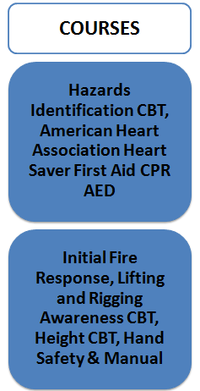
- H 2 S Awareness and Escape Hood
- Fire Warden
- STOP Observation (STOP)
- American Heart Association Heart Saver First Aid CPR AED (AHA)
- Initial Fire Response (IFR)
- Height CBT Course (Qatar)
- Hand Safety & Manual Handling CBT Course (Qatar)
- Hazards Identification CBT Course (Qatar)
- Lifting and Rigging Awareness CBT Course (Qatar)

Education

- Diploma in Information Technology from NIIT, Parry’s Branch, Chennai in 2005
- BA from Devaswom Board Pampa College, Mannar, Pathanamthitta, University of Mahatma Gandhi in 2004


IT Skills

Database Management: RDBMS, SQL Server 2005
Operating Systems: Windows 9x/2000/XP
Languages: SQL, C, C++, Java, J2EE
GUI: MS Office, Microsoft Excel Worksheets

Personal Details

Date of Birth: 31st May, 1984
Languages Known: English, Malayalam, Tamil and Hindi
LinkedIn Profile: om.linkedin.com/pub/minu-varghese/29/958/248/
Passport Number: F8988362, valid till 20/08/2016
Marital Status: Married

