Mohammed Riyas ck 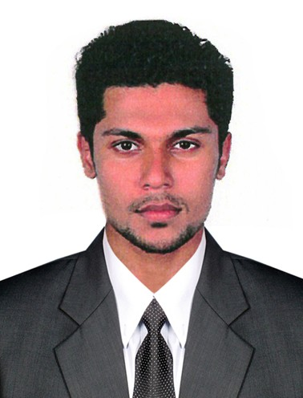
Chakkikulathil house
P.O Mannarmala
Pacheeri
Malappuram, Kerala
Pin: 679325
Mobile No: +91 9605160416
Email ID : riyasck05@gmail.com

Career Objective
To secure a professional position that utilizes my engineering education in the technical fields
by using teamwork, computer skills & creative thinking.

Work Experience
Jan 2014 - Mar 2014 | QC Engineer  NDT SERVICES (Onsite at RELIANCE REFINERY)  Jamnagar, Gujarat
Jul 2013 - Dec 2013 | DECIBEL Pattambi

Academic Projects
- Design And Fabrication Of Conveyor System For Pressing Machine(Main Project)
- Design And Analysis Of Horizontal Axis Wind Turbine Blade(Main Project)
- Differential Locking On Avoid Slip

Industrial Visits
- Salem Steel Plant(SAIL)
- Western Thomson(INDIA) Limited

Education
2013 - 2014 ASNT Level - II. Certificate in
- RT (Radiographic Test)
- UT (Ultrasonic Test)
- MT (Magnetic Particle Test)
- PT (Penetrant Test)
- VT(Visual Test)
Certificate in Post Diploma Specialization Course of Oil Field Engineering &
Quality Control From Decibel Institute Pattambi, Kerala
2009 – 2013 Maharaja Prithvi Engineering College, Avinashi 65 %
Anna University,
B.E MECHANICAL ENGINEERING
2008 – 2009 Institute Of Human Resource Development (IHRD) 64 %
Higher Secondary School, Perinthalmanna.
Higher Secondary,State Board
2006 - 2007 Darul Falah English Medium School, 60 %
SSLC, Central Board

Key Skills
- Self-motivated person
- Adaptive person
- Quick grasping power
- Leader ship
- Excellent learning capabilities

Software Exposure
- Pro Engineer
- AutoCAD
- MS Office (Word, Excel and Power Point)

Fields of Interest
- Production engineering
- Maintenance
- Quality control

Hobbies
- Exploring
- Listening to Music
- Sports- Cricket, Football, Chess
- Bike Riding, Modifications

Personal Information
Date of Birth : 6 November 1990
Gender : Male
Father’s Name : Usman CK
Nationality : Indian
Religion : Muslim
Languages known : English, Malayalam, Tamil, Hindi, Arabic
Address : Chakkikulathil house
P.O Mannarmala-679325
Malapuram, Kerala.
Phone No. : 04933 – 246314

Declaration
I hereby declare that the above written particulars are true and correct to the best of my knowledge and belief.

Place : (Mohammed Riyas Ck)
Date :

