Marwa Shirin   marwashirin786@gmail.com   +968 95675351 | +968 9364 7104 | 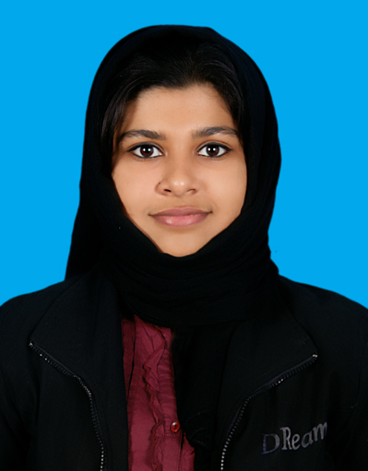
   | PERSONAL DETAILS
  Date of Birth  Sex |  | :  : | 31/07/1992  Female
  Nationality |  | : | Indian
  Religion  Languages |  | :  : | Islam  English, Hindi, Malayalam & Arabic
Strengths & Skills

Strong sense of Leadership
Able to work under pressure
Adapts well to multi-cultural environments
Goal oriented, Perfectionist
Good technical and communication skills
Excellent at customer service

Objective


Looking forward to start an enriching career with a reputed firm that will continue to allow me to develop on my technical knowledge in an environment that encourages on-going skill development all while contributing to the growth of the company.
CURRENT STATUS

Completed Electronics & Communication Engineering in August 2014.
 |  | EDUCATIONAL QUALIFICATIONS
 | Bachelor of Engineering(Electronics and communication) |  | Birla Institute of Technology, Mesra, Ranchi (Muscat centre) | CGPA: 7.1 2014
 | Class XII |  | Board Of Higher Secondary  Examination, Kerala | 87.4% | 2010
 | Class X |  | Board of Public Examination Kerala | 98% | 2008
RESEARCH WORK AND THESIS

Remote Energy meter monitoring with SMS.

WORK EXPERIENCE
Trainee | FRIENDI Mobile (Tele Communication Company) –Oman.  Call Center Executive | AirTel Telecom – Kannur, Kerala, India. |  | June.2012 to Sep.2012  July. 2011 to Sep. 2011
Data-entry | Bank Muscat – Oman. (Promotions)

TECHNICAL SKILLS
- AutoCAD
- G-Operator (Windows, MS Office ,Linux, Internet & E-mail)
- Windows 2007/XP, ‘98
- Basic Knowledge in P.C. Maintenance
- Languages – C Programming
- Languages - VHDL
- Languages - Mat lab(Beginners level)
- RDBMS - SQL(Beginners level)

ACHIEVEMENTS

- Won 1st prize for the final year project from Nizwa University in 2014.
- Won 2nd prize for the project in College TECH FEST in 2014.
- Participated in Caledonian College PROJECT EXPO.
- Won 3rd prize in KNOWLEDGE OMAN Quiz competition 2013.
- Passed AIEEE B.Arch Entrance examination with Rank-1121 in 2010.
- Qualified AIEEE B.E/B.Tech Examination 2010.
- Participated in many local competitions and events for drawing, painting and creativity.

EXTRA CURRICULAR ACTIVITIES

- Painting and Arts
- Photography
- Promotion Jobs
- Fine arts and Events Organization.

I hereby declare that the above given information is true and correct to the best of my knowledge and belief.

