


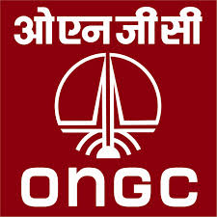
RESUME

NARAYAN L. KHALASHI,
Material Coordinator/Store Keeper /Logistic
At&Po: Dandi, Debhariyu Street,
Ta: Olpad, Di: Surat
Gujarat-394540, INDIA
narayan_khalashi@yahoo.com
Mobile No: +91-9998053579 (P)
+91-9913566098 (H)
+97430469001 (Doha Qatar)

Career Objective:

To be a successful Person and contribute growth and
Development of the organization .To accept challenges
and work hard to get through successful.
Personal Details:

Date of Birth/Age : 10-10-1987/26
Marital Status : Unmarried
Passport Detail : G 9373748 (E.C.N.R OK)
DOI : 08/09/2008
DOE : 07/09/2018
Languages known : Gujarati, Hindi, English
Father Name : Lalabhai S. Khalasi
Nationality : Indian
Educational Qualifications:

Mar-2004 (10th Class) - Central Board Secondary Education [C.B.S.E] Surat, Gujarat
- S.S.C second Class
- English Medium

Mar-2006 (12th Class) - Central Board Secondary Education [C.B.S.E] Surendranagar, Gujarat
- H.S.C(Commerce) First Class (12th Class)
- English Medium

Apr-2009 (B.com) - Maharaja Sayajirao University of Baroda [MSU] Baroda, Gujarat
- Accounting, Bachelor (B.com) Second Class.
- English Medium

Dec-2012 (MBA) - Institute of Management Technology [IMT] Ahmadabad, Gujarat
- Master of Business Administration in distance mode.(MBA)
- semesters completed
- English Medium



Training & Seminar
⇰» BOSIET: Basic Offshore Safety Induction & Emergency Training by OPITO Approved including ⇰» EBS: Emergency Breathing System Equipment of Kazakhstan Y.K.K. Validity up to 28-Sep-2016.
1) Safety Induction – Industry Overview; Offshore Hazards; Environment Awareness; Organization for Safety; Safety Management System; Permit to work; Living Offshore.
2) Helicopter Safety & Escape – Helicopter Travel; Helicopter Emergencies; Practical Escape from Ditched Helicopter Scenarios including Emergency Breathing System (EBS). HUET (Helicopter Underwater Escape Training
3) Sea Survival – Evacuation Theory; Evacuation & Escape Practical
4) Elementary First Aid – Essential First Aid in a Survival Situation
5) Firefighting & Self Rescue – Firefighting Offshore; Self Rescue; Practical Exercises.
Safety Training
1. Offshore Safety Induction.
2. Permit to work System (PTW).
3. Confined space Entry
4. Working at Height
5. Breathing Apparatus .
Total Work Experience: Total 5.2 Year
Total of 5+ years Experience in Store Keeper & Store In charge in India & Abroad with totally oil & Gas field Company.
Current Experience : Till Running

Company: Challenger Trading and Contracting (25-Aug-14 to till date) Doha Qatar
Designation: Store Supervisor

Past Experience: 1.1 Year

Company : Oil and Natural Gas Corporation (07-Jul-2013 to 12-Aug-14) Hazira,Surat,India
Employer : Neo Structo Constuction Ltd.
India’s Government Oil & Gas Company with onshore & offshore blocks
Designation: Store Supervisor
Job Responsibilities:
- Material Inward Register.
- Material Outward Register.
- Material Tracker Monthly (received, issued & balance)
- Bin Card System
- GRN Report.
- Indent Book For Requesting material.
- Purchase Order against Indent req.
- Petrochemical Goods Record : Ethylene, Ethylene bottom,Propylene,C5,C9,Thermal Cracked Gasoline, Toluene, Ethanol“Ethyl Alcohol”, Diethylene glycol,2-Ethyl hexanol,n-Butanol,n-Butyraldehyde,Isobutanol,Isobutyraldehyde,Isopropenylbenzene“alpha-methylstyrene”,Cumene
Bisphenol A (BPA),Phenol,

Past Experience:0 8 Month

Company : Agip KCO Kashgan Offshore Kazakhstan
Employer : Kazmunai services & Contracting LLP. (From: 23-Sep-2012 to 27-May-2013 )
Kashgan Offshore is an oil and gas Exploration and Production company, working in offshore and onshore oil and gas blocks in Kazakhstan & Caspian Sea. The huge source of Oil & Gas in this project.
Designation : Store In charge/Store Keeper
Job Responsibilities :
- Manage Inventory Control System.

- Systematic Record & Knowledge for Below Category

- All type of World class Tools used at Oil & Gas Project
- All type of PPE Items : Winter & Summer

- All type of Consumable Tools Item ex. Nut, Bolt, Sleeves, Grading Disc, and Welding Road etc.
- Maintain Cable Drum Yard
- All type of Stationary Item
- All type of Oil and Gas Industries Instrument.
- Mechanical Completion Material: Cable Drum, Instruments, Heat Tracing, Tubing, Light Fixture, JB, Panel, Channel & etc.
- Experienced in Materials, Material Coordination, Warehouse Supervising & Stock Control as well as Design Database & inventory, Project Spare Parts Specialist.
- Handle Supervisor Logistic Responsibility
- Making Material Request(MR ),Delivery Note (DN) & their Status Report
- Coordinate for Customs and Transport Formalities for materials and equipments imported via both Overland(Chopper) and by Sea(Boat).
- Preparing Material Requirement Planning (MRP) Report.
- Implementing & maintaining all ISO required formalities & documentation fulfilling of Internal Audit Compliances
- Issue and Deliver Material to various Unit, Department and Individual.
- Reports Daily Store Report to Project Manager
- Maintain House Keeping around & Inner Part of warehouse Daily.

Past Experience: 2.8 Year

Focus Energy Ltd. (From: 04- Feb-2010 to to 19-Sep-2012) Hazira, Surat, Gujarat
Focus Energy is an oil and gas Exploration and Production company working in offshore and onshore oil and gas blocks in India. (Offshore Rig at Surat Hazira)
Designation : Store Officer
Job Responsibilities : Worked with Offshore Rig Rotation

- Managing the offshore goods and stock Report.
- Maintain Record for all Tools
- Posting of Issues Slips / Vouchers & Good Receiving Note.
- Receiving of Material and stored Entry by computer.
- Raise Material Purchase Requition by mail and also by ERP Website.
- Maintain Order level of Materials.
- Issue and Deliver Material to various Unit, Department and Individual.
- Reports Daily to Vice President Regarding Store total situation.
- Manage Inventory Control System
- Supervise Store Personal and Monitor their Activities
- Handling also Reconciliation Statement Entry in Tally.
- Updating the Database of Material using by Computer or Manual.
- Basic knowledge of marine related item & Issue. (Shipping work)

Past Experience: 9th Month

Indian Oil Corporation Ltd with Sub Contract Samsung Engineering Co. Ltd (From: 01- May-2009 to 31-Jan-2010) Hazira, Surat, Gujarat
The Gujarat Refinery is an oil refinery located at Koyali (Near Baroda) in Gujarat, Western India. It is the largest refinery owned by Indian Oil Corporation.
Designation : Store Keeper
Job Responsibilities :

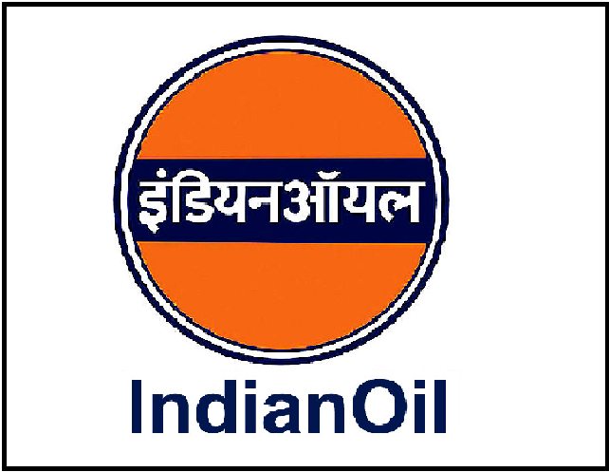
- Managing the all refinery Materials.
- To exercise general control over all activities in Stores Department
- To ensure safe keeping both as to quality and quantity of materials.
- To maintain proper Tools Record
- To reserve a particular material for a specific job when so required.
- To issue materials only in required quantities against authorised requisition notes/material lists.
- To initiate action for stoppage of further purchasing when the stock level approaches the maximum limit.

IT Skills:

- Tally 9 (Bank Reconciliation Statement)
- SAP : Module –MM & IM (At Agip KCO Offshore)
- Amos (For Offshore & Onshore Inventory)
- ERP (Focus Energy Ltd.)
- MS Office
- Install & Uninstall of Software, Operating of all business & Administrative Software and application
- Window Basic Properties
- Operating all type of Printer and their Properties
Self Summary:
Well rounded knowledge and expertise in the Oil and Gas Department for position of Material Coordinator/Store supervisor/Store Keeper/Logistic Coordinator .Totally 05 Year & above experience in Oil and Gas field with Onshore and offshore Location. Well experienced and educated. Whole Experience related to Marine area. Strong skill in computer, Proficiency of English Language, Strong Communication & team building. Professional in Microsoft Access Program, familiar with different Projects Professional Software’s regarding Warehousing, Purchasing & Procurement inventory Control such as: IPMS ,SAP & ERP
.Declaration:
I hereby declare that the information furnished above is true to the best of my knowledge.
Ref:-
Mukesh Panchal (Store Manager)
Narayan Khalashi Nazir Shaik (Admin Officer: Focus Energy Ltd.)
(Applicant) Vijaykumar (Project Manager: Kazmunai Services, Kashgan Ofshore)

